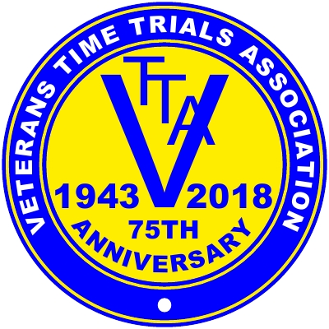
Promoted for and on behalf of Cycling Time Trials under its rules and regulations

The RESULTS SHEET for the

East Anglia VTTA 10 mile Individual & Tandem

Time Trials

COURSE E2/10 – SATURDAY 2nd SEPTEMBER 2023

AWARDS.

Fastest Male on AAT.

Kevin Tye. VeloRefined Rule 5 17.38 £35
Keith Dorling Team Bottrill 17.58 £30
Chris Dyason Cambridge C.C. 18.08 £25
Andrew Meilak VeloRefined Rule 5 18.17 £20
Mick Stevens, Simon Smart, Kevin Wood, Robert Watson, Sean Hunt, Mark Jones
- all £15 each.

Fastest Female on AAT.
Susan Semple Legato Racing Team 18.41 £35
Deborah Sheridan Warwickshire R.C. 18.55 £30

Team of 3 Men on AAT. VeloRefined Rule 5 (K.Tye, A Meilak, S. Hourigan) 56.33 £20 each
No Women’s Team completed.

Best East Anglian Vet on AAT. Ron Fisher / Jack King Memorial Shield - Keith Dorling.

Fastest Tandem on AAT.
John Swanbury/Alistair Banks V.C.Baracchi 19.38 £15 each.

Prize winners will need to e-mail me their bank details asap for prizes to be paid.
.
My thanks go to the following people.

Keith West - for the start and results sheets and the results board on the day (plus countless other bits of advice).
Tim and Becki Groves for Timekeeping. James Wood for results feed to Keith on the day.

Emily Varley, Andy Bright, Trevor Parrish, Maggie Parrish and Tony Cork (marshalling). Richard Moule and Matt O’Brien for pushing off, Dave Nock for signing on and kitchen duties and Keith Dorling for signage (before and after the race) and finally, Lisa at Hardwick Sports and Social Club.
I could not run this event without this brilliant team.

